**\*\*\* This is where I think the problem is \*\*\*\***

**We have a sample that has 4 contributors we use sim.mix to make the repliste in step 8 and the list of alleles for prosecutor and the defense. Later we use noncom.sus alleles to calculate LRs. That doesn’t seem right.**

**Sample: Sim.Mix**

**Noncom.sus: Indivdual 10,2,29,26**

indivdual

74,91,55,93

Alleles: for sim.mix @ K



Alleles for noncom.sus @ k



For non contributors :

FUNCTION is CALLED:

1. A file is input by the user
2. Genotypes are simulated using simugeno with respect to the tabfreq object == **sim.genotypes**
3. The non contributor suspect data is generated using simumix object and sim.genotypes == **noncom.sus**

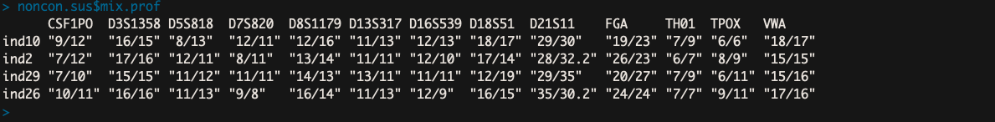

1. A Matrix that holds allele frequencies according to the input file is generated == pop.afs.matrix

**Beginning of loop:** else if (non.or.truecontrib == 1)

1. Sim.mix is created. When the function was called the number of contributors was set to four, so four of the 100 generated individuals are randomly selected and saved to sim.mix.

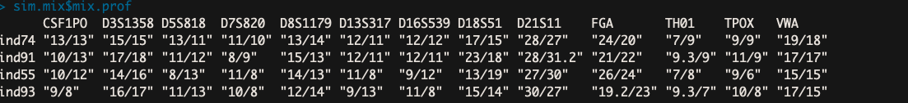

1. We initiate an empty vector to hold LRs for each loci at a given simulation == singleLR_vector <- c()

**Beginning of while loop : while (k < 14)**

1. We save the alleles at a given K to the empty vector prosecutor.all.atk.

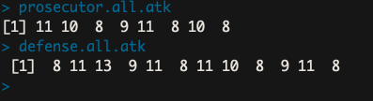

1. A single LR is calculated at the current loci (4) using the

#

**single_LR <- LR( Repliste** = c(sim.mix$mix.all[[k]])

**"8" "9" "10" "11"**

Tp = c(prosecutor.all.atk,

as.numeric(strsplit(**noncon.sus**$mix.prof[1,k], "/")[[1]])),

**12 11**

Td = c(defense.all.atk),

**8 11 13 9 11 8 11 10 8 9 11 8**

Vp = 0,

Vd = c(as.numeric(strsplit(**noncon.sus**$mix.prof[1,k], "/")[[1]])),

**12 11**

xd = 1,

xp = 0,

theta = 0,

prDHet = c(0.2,0.2),

prDHom = c(0.04,0.04),

prC = 0,

freq = pop.afs.matrix[[k,1]]

)

